Ryan Adams, CISSP, entered the field of IT as the founder of an IT services company focused on providing personalized support to small/medium businesses. After building a foundation of broad technical experiences including desktop/server support, network design and implementation, embedded system design, user training, and IT security, he transitioned into an IT Security specific role. Since that time, he has worked in multiple capacities as a Security Auditor/Engineer/Architect and further developed his skills in areas including vulnerability management, penetration testing, security operations management, incident response, secure application development, and risk assessment. | 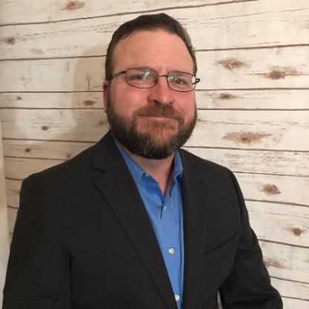  Donald “Donnie” Mayo is the Director of Information Security and IT Governance for Ports America, the nation’s largest terminal operator and stevedore, operating in more than 42 ports and 80 locations. Donnie is responsible for leading Ports America’s Information Security Program as well as Project Management and IT Governance Offices for Ports America.  Prior to joining Ports America, Donnie held several positions in Information Security in the federal government, non-profit and insurance industries. Donnie retired from the United States Marine Corps in 2014, rising to the rank of Major. His last position was Deputy CIO of the 1st Marine Logistics Group, coordinating and leading IT and Cyber Security services for a unit of over 14,000 Marines and Sailors providing logistics support to the First Marine Expeditionary Force.  Donnie has a master’s degree in computer science from the Naval Postgraduate School. Donnie also participated in the Syracuse University Veteran’s Career Transition Program in Program Management. Donnie holds the CISSP, as well as numerous Federal Government information security and procurement/acquisitions certificates.  Donnie endeavors to be a businessman who happens to know IT and cybersecurity.” | Ken Rowe, Security Architect, PetSmart  Ken has more than 35 years of experience in Information Security that includes a distinguished career at the National Security Agency and a variety of roles in industry and academia, including the CISO for the University of Illinois’ University Administration. Ken developed guidance and training for NSA’s initial cadre of InfoSec Engineers, and initiated and mentored the creation of the Systems Security Engineering Capability Maturity Model (which became ISO/IEC 21827-2008). For more than a dozen years, he has been auditing or building compliance programs for Sarbanes-Oxley, HIPAA, FFIEC, GLBA, PCI DSS, ISO 27001, and NIST Cyber Security Framework (CSF).  Ken obtained his Bachelor of Science in Mathematics from Illinois State University. Under a Fellowship at NSA, he completed PhD studies (ABD) and a Master of Science in Computer Science at the University of Maryland, Baltimore. | 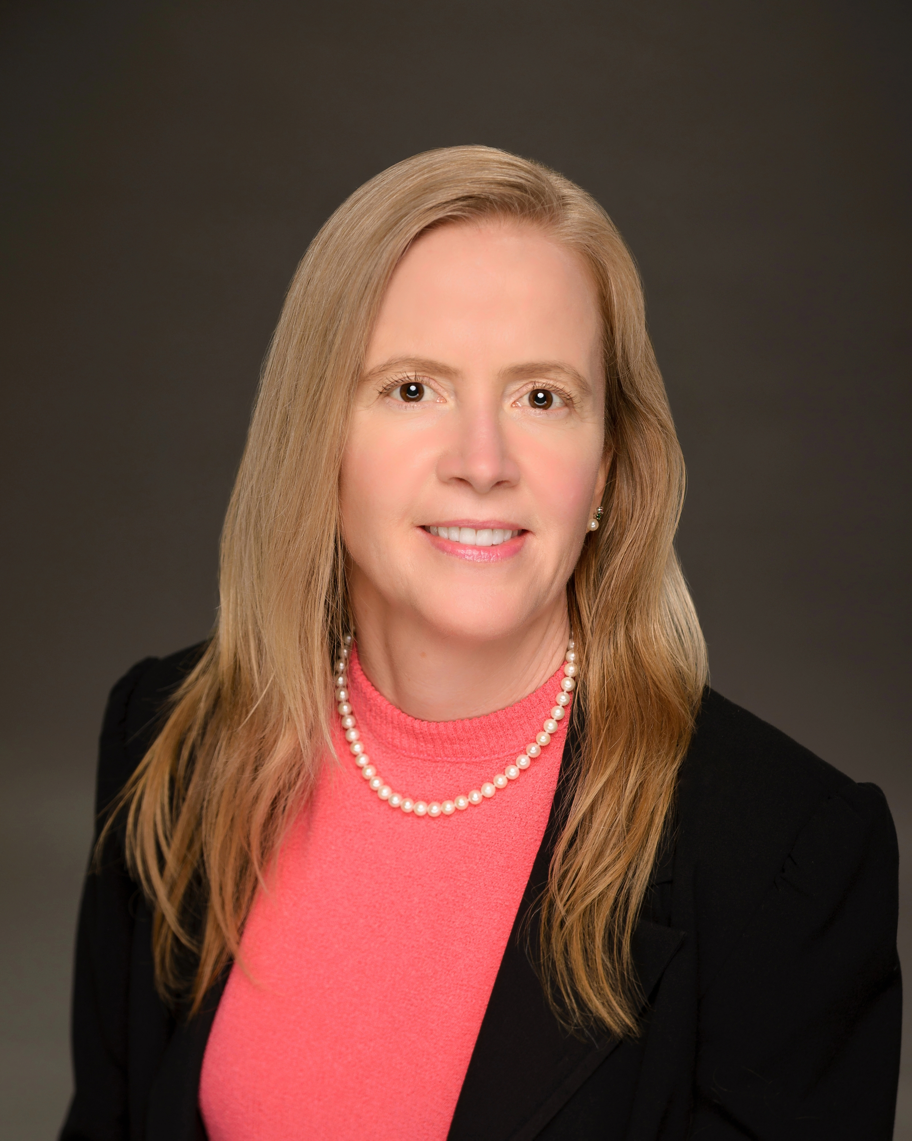  Kristy Westphal is a versatile information technology professional of 24 years with specific experience in providing advisory and management services in the areas of information security and risk is currently employed as the Senior Manager of Security Tools at Charles Schwab. She has previously worked as the Director, Risk and Assurance with Vantiv and Director, Security Operations for T-Systems North America. Experience in the Information Security field has led to the achievement of CISSP, CISA, CISM, CIPP/US, and CRISC. Specializing in leadership and program development, specific expertise in security areas includes: process analysis, risk assessments, security awareness programs, operating system security, network security, incident handling, vulnerability analysis and policy development.

